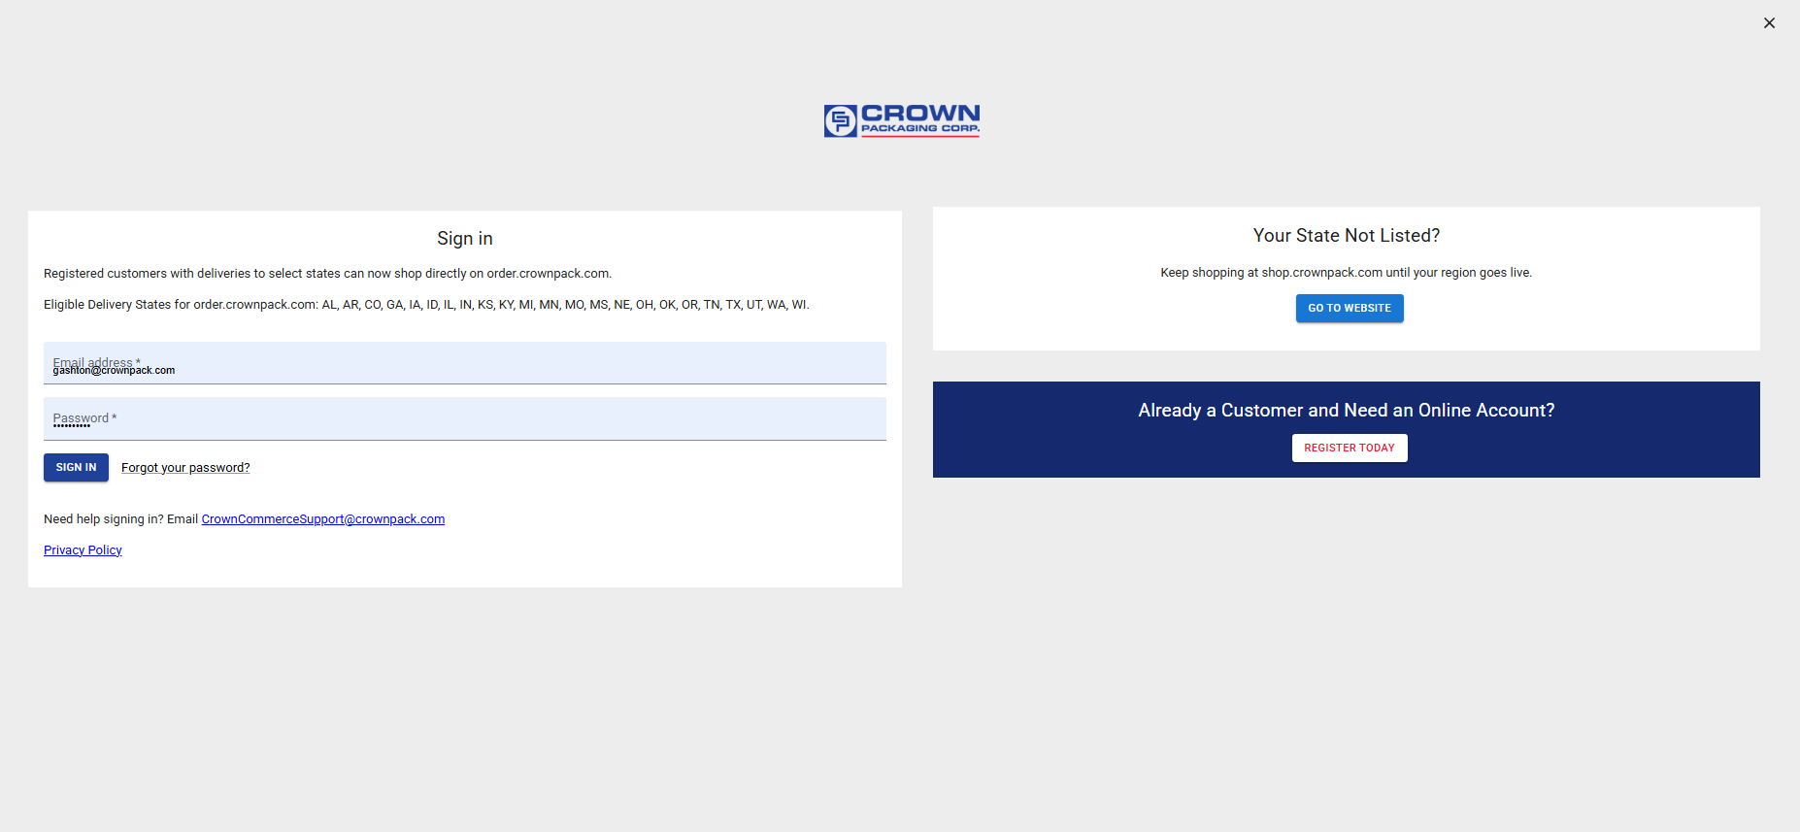

Requested Changes:

Sign In:
We are no longer restricting the website access to only specific states.
- Please remove the two sentences above the Sign-in fields (email address / password) as they are no longer required.
- Please remove the Privacy Policy link from here

Your State Not Listed?
This no longer applies as we ship to all states

Already a customer
- Change heading
  - From: “Already a Customer and Need an Online Account”
  - To: “Sign Up for an Online Account”
- Change Button label
  - From: “REGISTER TODAY”
  - To: “CLICK HERE TO REGISTER”
- We are going to use the same registration form for both NEW and Existing Crown customers…at least for now.
- CHANGE TO REGISTRATION FORM:
  - Because of this decision, could you please add a checkbox at the top of the page that asks if they are already an existing customer. Example from a different site:
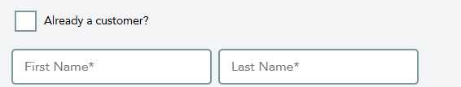

NEW - Add disclaimer
- We want to add text at the bottom of this screen:
- “Online ordering and shipping available only to qualified, registered customers in the US. Read the Terms of Access for more details. Visit shop.crownpack.com to request a quote for international orders and for additional product options.”
  - As shown above, please have shop.crownpack.com be a hyperlink to that page
- Please add the link to Privacy Policy below this disclaimer
- Please create a hyperlink for Terms of Service
  - We will send you the URL to use after we have finalized the language we want to use.

Empty Space / UI Design
- Overall – I would appreciate it if you could have a UI designer on your team take a look at this page and make some recommendations to you on how to make this look good.
  - I am NOT a UI designer so I would appreciate someone more creative to make suggestions
  - Some things even I can see:
    - There is lots of empty space
    - Plain looking
    - Does it really need to be a full screen page for this or can we do a more sophisticated + smaller pop-up

